Assignment 11.2
Name :M.PRAVEEN
HT.NO : 2303A51061
B.NO : 16

Task Description -1 – (Stack Using AI Guidance)
• Task: With the help of AI, design and implement a Stack data
structure supporting basic stack operations.
Expected Output:
• A Python Stack class supporting push, pop, peek, and empty-
check operations with proper documentation.

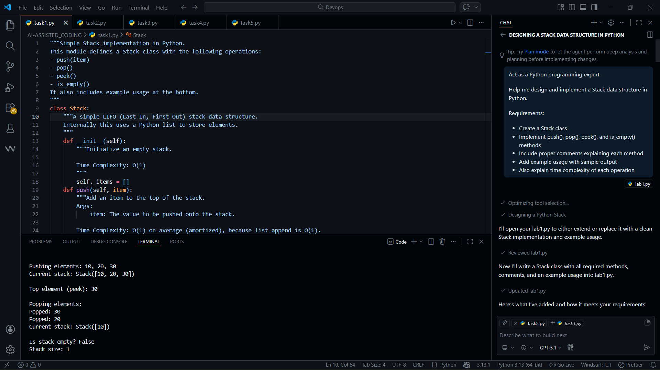

Implemented a Stack class backed by a Python list.
Methods:
- push(item): adds an element to the top.
- pop(): removes and returns the top element, raises IndexError if empty.
- peek(): returns (without removing) the top element, raises IndexError if empty.
is_empty(): returns True if there are no elements.

Task Description -2 – (Queue Design)
• Task:Use AI assistance to create a Queue data structure
following FIFO principles
Expected Output:
• A complete Queue implementation including enqueue, dequeue,
front element access, and size calculation

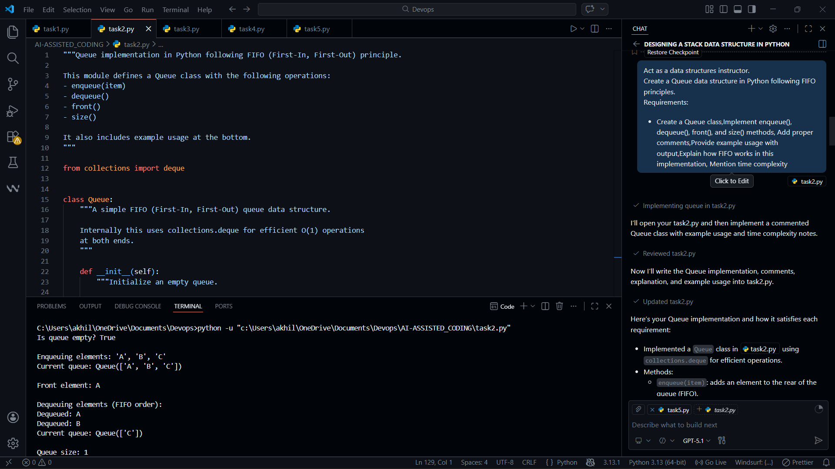
- Implemented a Queue class using collections.deque for efficient operations.
- Methods:
enqueue(item): adds an element to the rear of the queue (FIFO).
dequeue(): removes and returns the front element; raises IndexError if empty.
front(): returns (without removing) the front element; raises IndexError if empty.
size(): returns the current number of elements.
is_empty(): helper to check if the queue has no elements.

Task Description -3 – (Singly Linked List Construction)
• Task: Utilize AI to build a singly linked list supporting insertion
and traversal.
Expected Output:
• Correctly functioning linked list with node creation, insertion
logic, and display functionality.

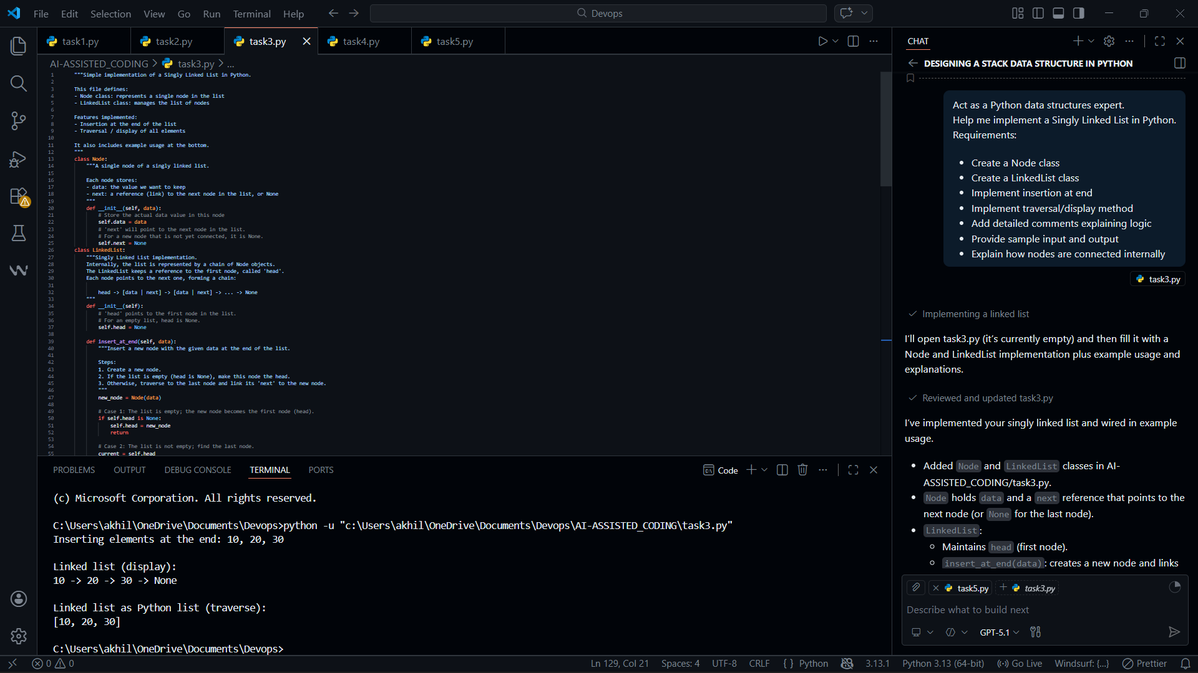

- Added Node and LinkedList classes.
- Node holds data and a next reference that points to the next node (or None for the last node).
- LinkedList:
  - Maintains head (first node).
  - insert_at_end(data): creates a new node and links it at the end by walking from head to the last node and updating its next.
  - traverse(): walks from head via next, collects data values into a Python list, and returns it.
  - display(): prints the list in the form 10 -> 20 -> 30 -> None.
Task Description -4 – (Binary Search Tree Operations)
• Task: Implement a Binary Search Tree with AI support focusing
on insertion and traversal.
Expected Output:
• BST program with correct node insertion and in-order traversal
output.

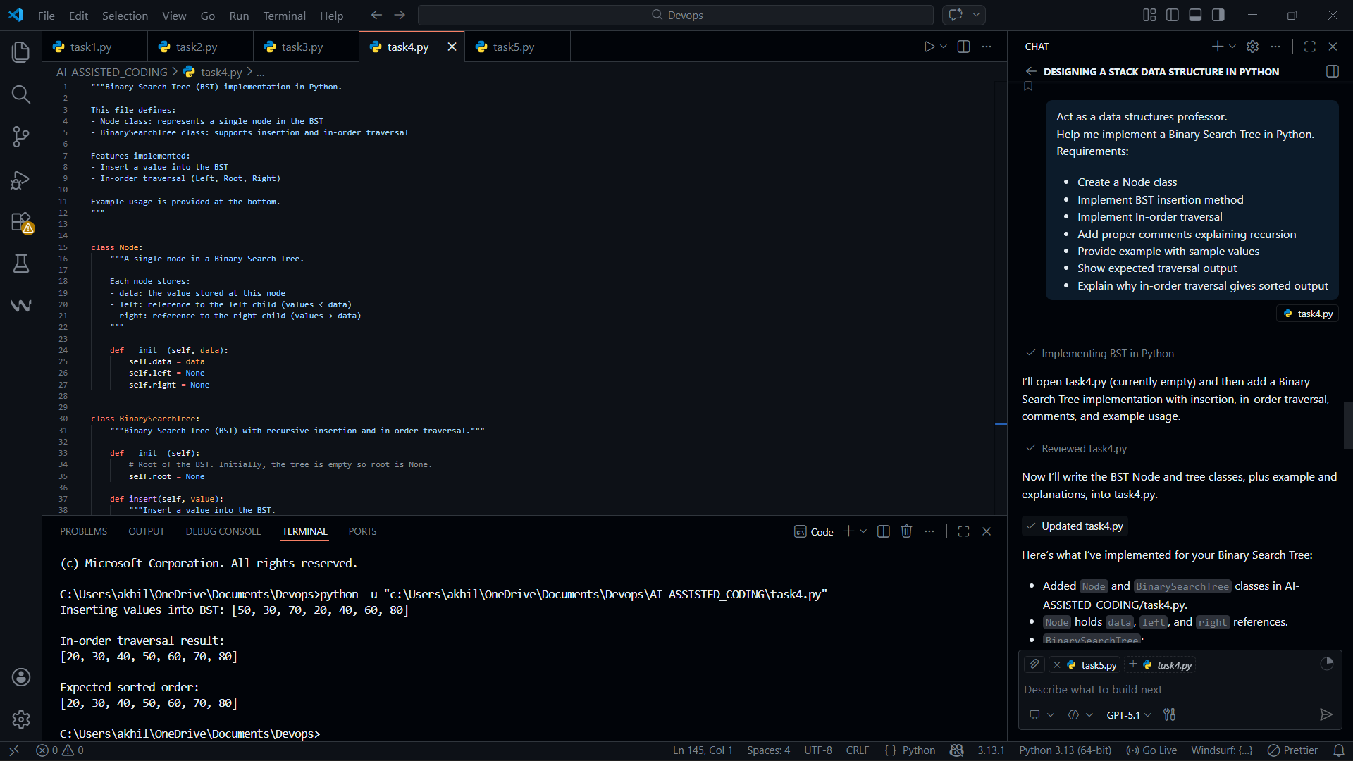
Added Node and BinarySearchTree classes in AI-ASSISTED_CODING/task4.py.
Node holds data, left, and right references.
BinarySearchTree:
insert(value): public insert method using _insert_recursive(node, value):
Base case: if node is None, create and return a new Node.
Recursive case: go left if value < node.data, right if value > node.data, then return node to maintain
links.
inorder_traversal(): returns a list of values; uses _inorder_recursive(node, result):
Base case: node is None → return.
Recursive case: traverse left, visit node (append data), traverse right.
Comments in both recursive helpers explain base/recursive cases clearly.

Task Description -5 – (Hash Table Implementation)
• Task: Create a hash table using AI with collision handling
Expected Output:
• Hash table supporting insert, search, and delete using chaining or open
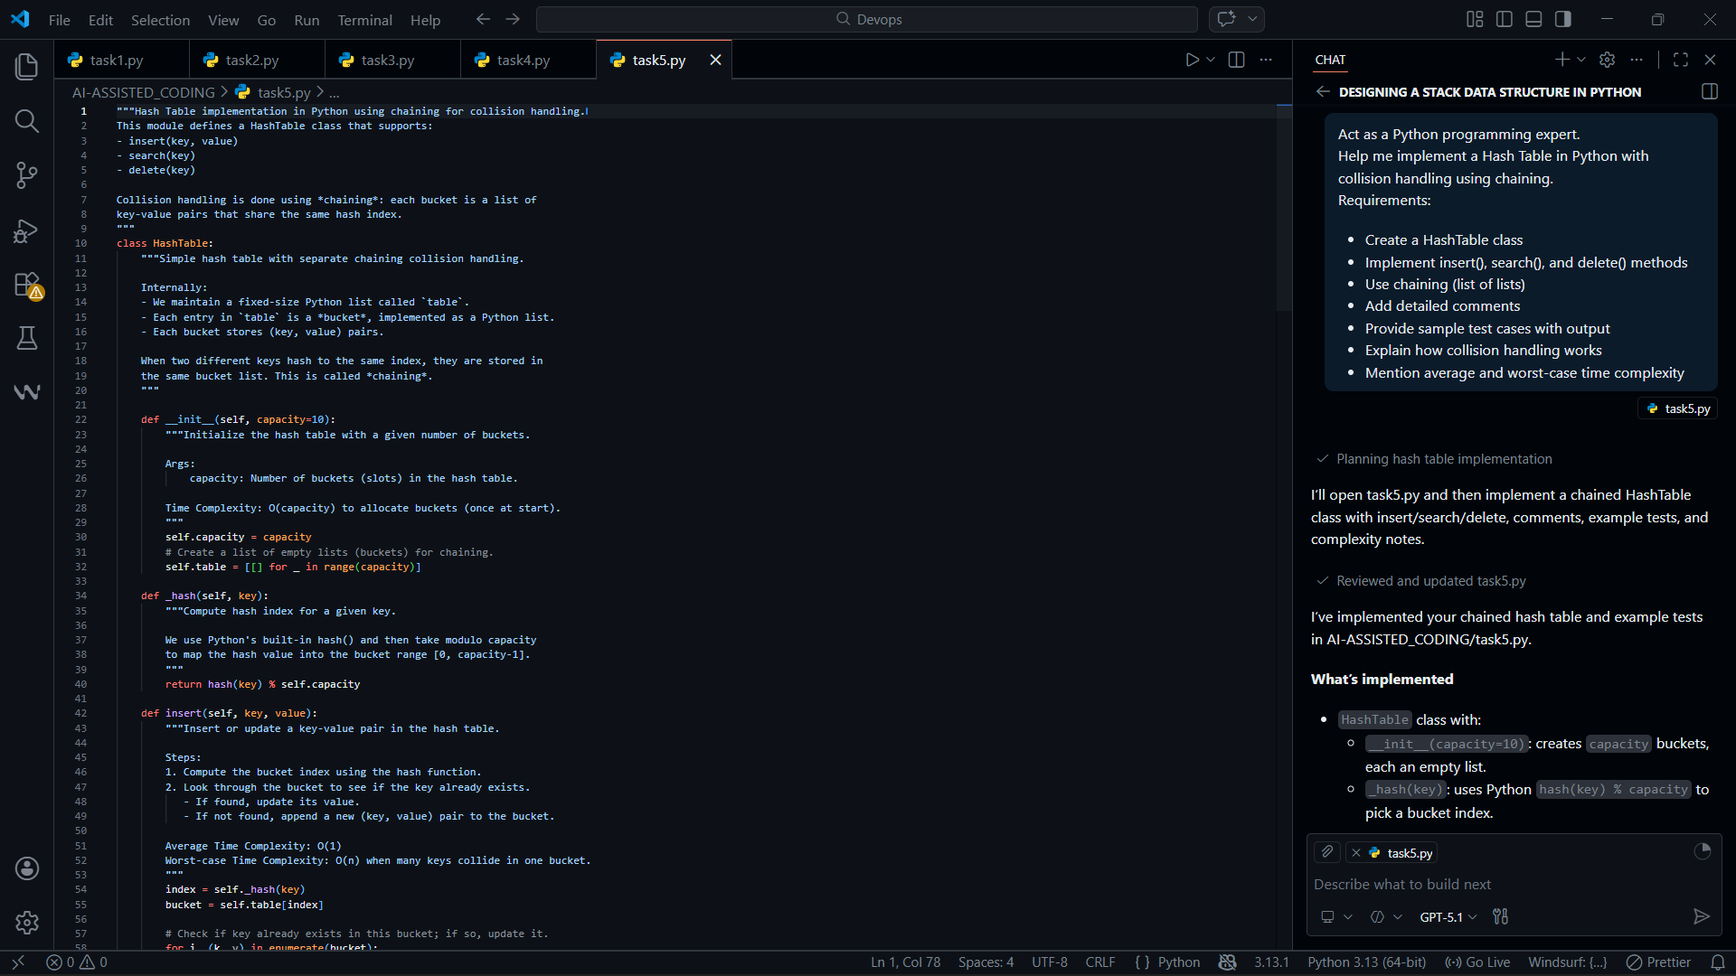
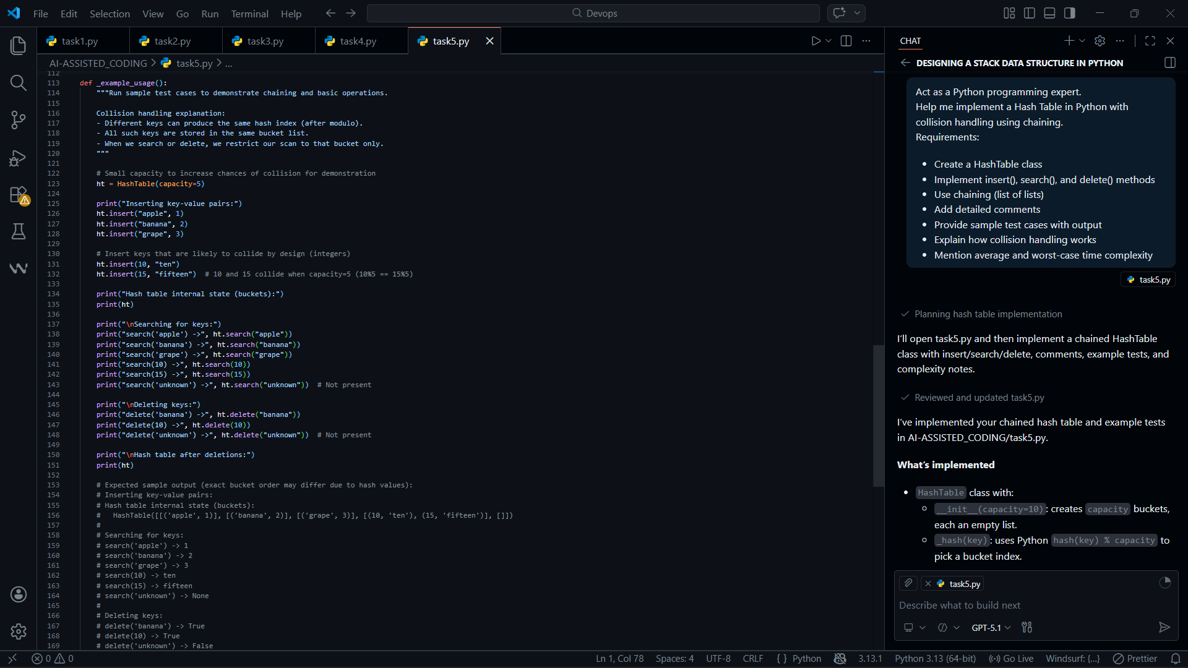
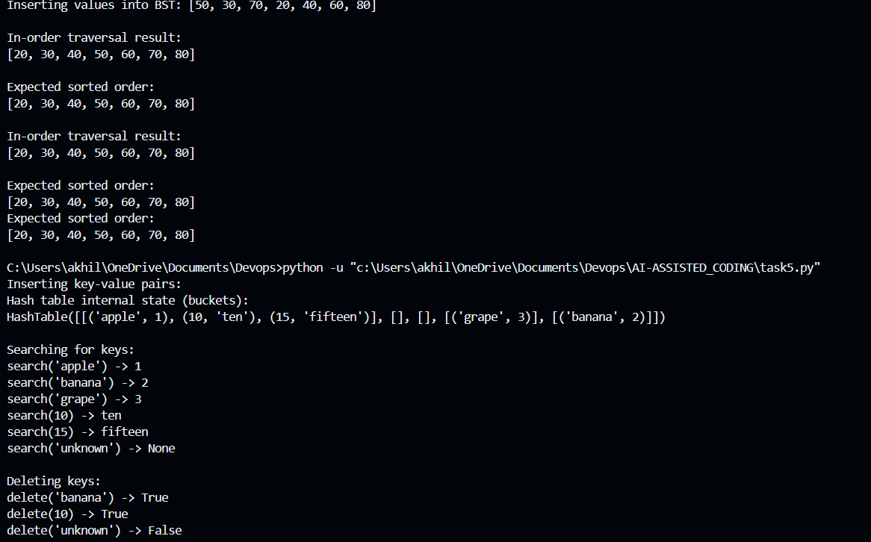

- HashTable class with:
  - __init__(capacity=10): creates capacity buckets, each an empty list.
  - _hash(key): uses Python hash(key) % capacity to pick a bucket index.
  - insert(key, value): updates existing key or appends (key, value) into the bucket.
  - search(key): scans the bucket for key, returns the value or None.
  - delete(key): removes (key, value) from the bucket, returns True/False.
- Chaining:
  - self.table is a list of lists (buckets).
  - Each bucket stores multiple (key, value) pairs that share the same index → this is collision handling by chaining.

